**A title should be the fewest possible words that accurately describe the content of the paper (Sentence case, centre, bold, 14pt)**

**Author Name1, Author Name2, Author Name3 (11 pt)**

1 Affiliation1 (9 pt)

2 Affiliation 2 (9 pt)

*e-mail: author1@email.com*

|  |  |  |
| --- | --- | --- |
| **Article Info** |  | **ABSTRACT** (11 PT) |
| ***Article history:***  Received : DDMMYY  Revised : DDMMYY  Accepted : DDMMYY |  | A well-prepared abstract enables the reader to identify the basic content of a document quickly and accurately, to determine its relevance to their interests, and thus to decide whether to read the document in its entirety. The Abstract should be informative and completely self-explanatory, provide a clear statement of the problem, the proposed approach or solution, and point out major findings and conclusions. The Abstract should be 100 to 200 words in length. The abstract should be written in the past tense. Standard nomenclature should be used and abbreviations should be avoided. No literature should be cited. The keyword list provides the opportunity to add keywords, used by the indexing and abstracting services, in addition to those already present in the title. Judicious use of keywords may increase the ease with which interested parties can locate our article (10 pt). |
| ***Keyword:***  First keyword, Second keyword, Third keyword, Fourth keyword, Fifth keyword |
|  |
| |  |  | | --- | --- | |  | ©2023 Authors. Published by LARTC . This work is licensed under a Creative Commons Attribution-NonCommercial 4.0 International License.  (https://creativecommons.org/licenses/by-nc/4.0/) | | | |  |  |

**INTRODUCTION (Capital, bold , Times new romance 11 pt)**

The introduction contains (1) research background; (2) research objectives; (3) research contributions (benefits), and (4) include a review of the previous literature followed by the novelty of the research or the originality of the article and try to have references to articles from journals from the last 10 years that strengthen the justification for originality. At the beginning of the paragraph one time tab, the introduction should not be divided into the background, problem formulation, and objectives sub-chapters. Citations are written in body note format and are relevant to the bibliography (it is recommended to use the Mendeley application or other reference management application programs such as EndNote, Reference Manager, or Zetero) (Times new romance 11, 1.5 line spacing, before after 0).

**RESEARCH METHODS**

The research method includes the type of research, research population, research sample/subject, and technical data analysis. Can use multilevel numbering if necessary. Don't forget to provide a title and picture number (below the picture and serial number starting from number 1) and the title and table number (above the table with serial number starting from number 1). (Times new romance 11, 1.5 line spacing, before after 0).

**RESULTS AND DISCUSSION**

The results and discussion contain research findings and scientific discussions. Adequate data must support research findings. This section should answer the research hypothesis. And describe the comparison with the results of previous studies. The results and discussion at least contain (1) (what/how elements) whether the data presented has been processed (not raw data), is stated in the form of tables or pictures, and is given easy-to-understand explanations; (2) (the why element) in this section of the discussion shows a link between the results obtained and the basic concepts and/or hypotheses. Actual and apparent facts must support the discussion; and (3) (what else element) whether there is conformity or contradiction with the results of previous research.

Please avoid writing in the form of bullet numbering or list item models; preferably, even though it is a list item, it is still written in descriptive paragraphs. Articles can be written in Indonesian or English. Articles must be written according to the template. The maximum number of pages is 20 with an A4 writing field size and normal margin format (2.54 cm x 2.54 cm). Foreign words or terms use italics or italics. (Times new romance 11, before after 0). When loading Tables and Figures, the numbering continues the previous number. Each table and figure must be given a title. (Times new romance 11, 1.5 line spacing, before after 0)

**Table**

The table is in the middle. Use times new roman and font size of 8 to 11. Horizontal lines in the middle of the table do not need to be displayed, only the headings and the last part are displayed, nor should there be vertical lines. Make sure you create the table correctly via the Insert Table menu. Tables should be referenced in the text by writing something like: '... (Tables are written with a big 'T').

**Table 1 Title of the table, use case sentence**

(capital letters and bold)

|  |  |  |
| --- | --- | --- |
| No. | This line |  |
| 1 | This table contents, if not enough, you can reduce the font size to 8 points. Don't go any smaller than this, unless you want your readers to hurt your eyes. :-) | Regular table fill font |

Try not to truncate the table on different pages unless the size exceeds one page. If you have to truncate, don't forget to rewrite the header row for each column, given the same table serial number, and replace the title with Continuation. The table title does not end with a period. Tables do not need to use vertical lines.

**Picture**

As with tables, make sure each figure has a sequence number and a title. Make the images you use to look like they're professionally made and don't need to be framed. Make sure to use black-and-white images.

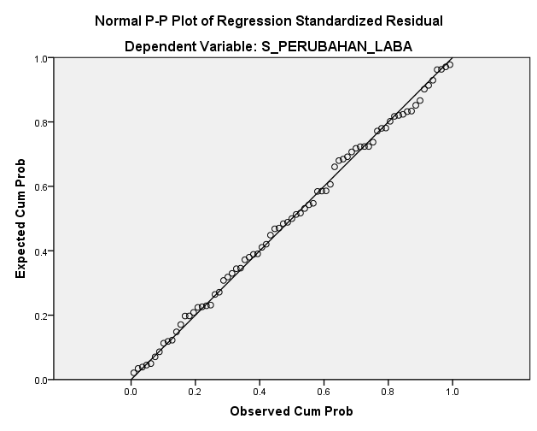

**Picture 1 The title of the image (also uses the sentence case, bold)**

**CONCLUSION**

Write down the findings or conclusions if you feel the conclusions need to be numbered, please use them in the usual way.

**BIBLIOGRAPHY**

Written using the American Psychological Association 7th edition style. References should be composed of 80% journal articles and 20% books, references from the last 10 years. Use the Mendeley application or other reference management programs such as EndNote, Reference Manager, or Zetero. The bibliography does not need to be divided into sections. The number of references in the bibliography is at least 15 references. The following is an example of writing a library:

**Books :**

Sugiyono. (2014). *Metode penelitian kuantitatif kualitatif dan R&D*. Alfabeta.

**Journal :**

Artaningrum, R. G., Budiartha, I. K., & Wirakusuma, M. G. (2017). Pengaruh profitabilitas, solvabilitas, likuiditas, ukuran perusahaan dan pergantian manajemen pada audit report lag perusahaan perbankan. *E-Jurnal Ekonomi Dan Bisnis Universitas Udayana*, *6*(3), 1079–1108.

**Dictionary/Encyclopedia – print :**

VandenBos, G. R. (Ed.). (2007). *APA dictionary of psychology*. Washington, DC: American Psychological Association.

**Dictionary/Encyclopedia – online :**

Arcus, D. (2001). Attention deficit / hyperactivity disorder (ADHD). In B. Strickland (Ed.), *The Gale encyclopedia of psychology*. Diakses dari http://www.gale.cengage.com/

**Conference/Seminar paper in published proceedings – print :**

Edge, M. (1996). Lifetime prediction: Fact or fancy? In M. S. Koch, T. Padfield, J. S. Johnsen, & U. B. Kejser (Eds.), *Proceedings of the Conference on Research Techniques in Photographic Conservation* (pp. 97-100). Copenhagen, Denmark: Royal Danish Academy of Fine Arts.

**Conference/Seminar paper in published proceedings – online :**

Tester, J. W. (2008). The future of geothermal energy as a major global energy supplier. In H. Gurgenci & A. R. Budd (Eds.), *Proceedings of the Sir Mark Oliphant International Frontiers of Science and Technology Australian Geothermal Energy Conference*, Canberra, Australia: Geoscience Australia. Diakses dari http://www.ga.gov.au/image_cache/GA11825.pdf